PHP Windows server 2019

1. Log into the Windows server with an account with admin privileges



1. Download the Non-Thread Safe (NTS) VS16 x64 PHP for Windows .zip [Download](https://windows.php.net/download/)



1. Download Microsoft Visual C++ [Download](https://aka.ms/vs/16/release/vc_redist.x64.exe)



1. Install Microsoft Visual C++



1. Extract the downloaded PHP for Windows .zip file



1. Rename the extracted folder PHP



1. Cut the PHP folder to a safe location to run from, such as C:\Program Files



1. Click the Start button > Search Control > Click Control Panel



1. Click on System > Advanced system settings



1. Click the Environment Variables... 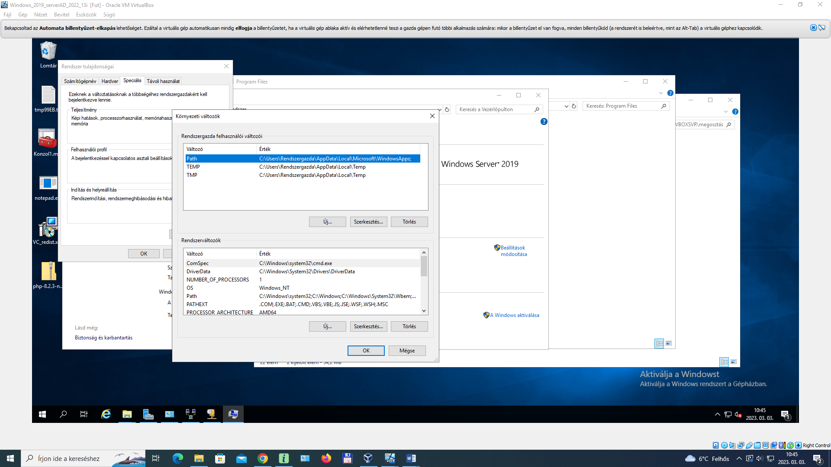



1. Edit the System Path variable



1. 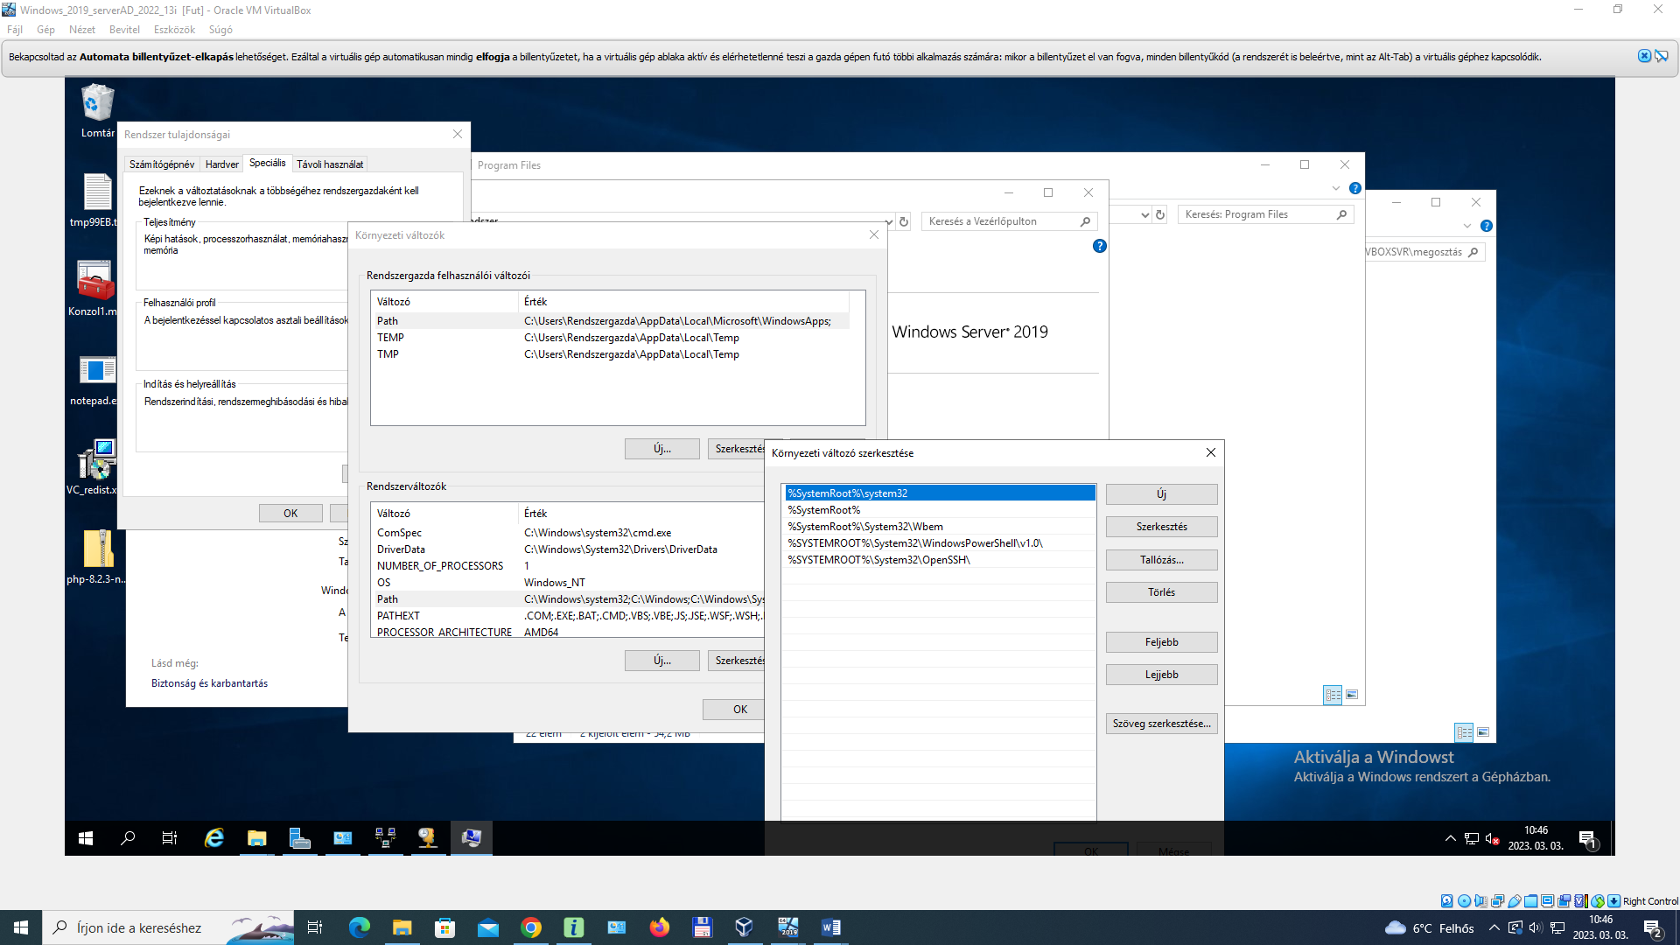
2. Click the New button



1. Add the PHP installation directory (ie C:\Program Files\PHP\



1. 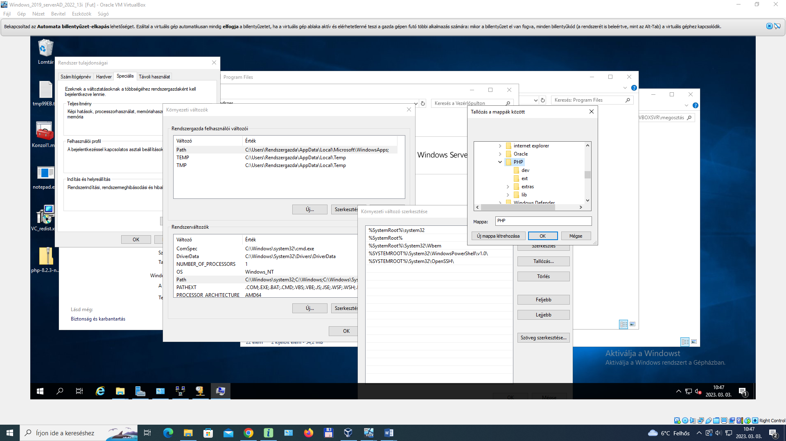
2. Click OK to all open dialog windows



1. 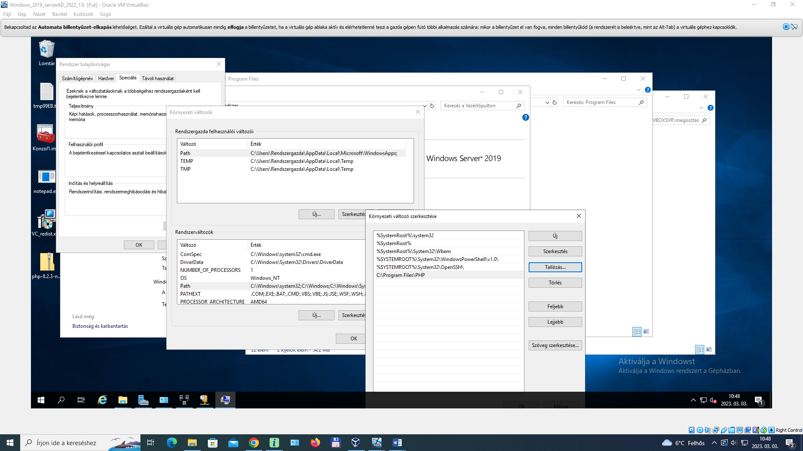
2. Launch Server Manager from the Start



1. Click Add roles and features



1. Click Next on the Before you begin screen



1. Select Role-based or feature-based installation > Next



1. Leave Select a server from the server pool selected and select the current Windows server > Next



1. Expand Web Server (IIS) > Expand Web Server > Expand Application Development > Check the box next to CGI to select it



1. Click Next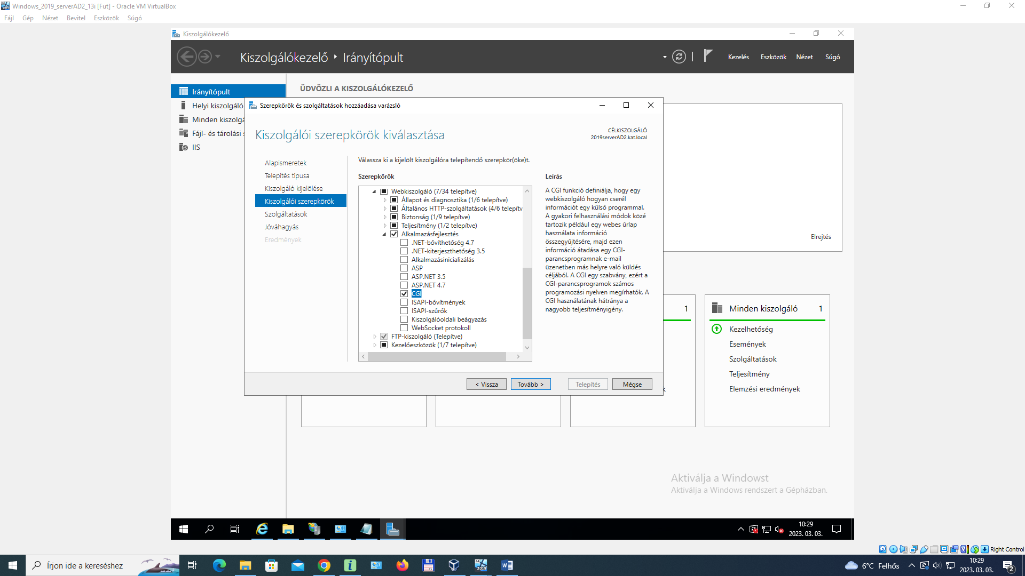



1. Click Next on the Select features screen



1. Click Install on the confirmation screen



1. Leave the installation progress screen open until the install completes



1. Once the Feature installation completes successfully, click the Close button



1. Back in Server Manager, click Tools > Internet Information Services (IIS) Manager



1. Click the server name to select it > Double click Handler Mappings



1. 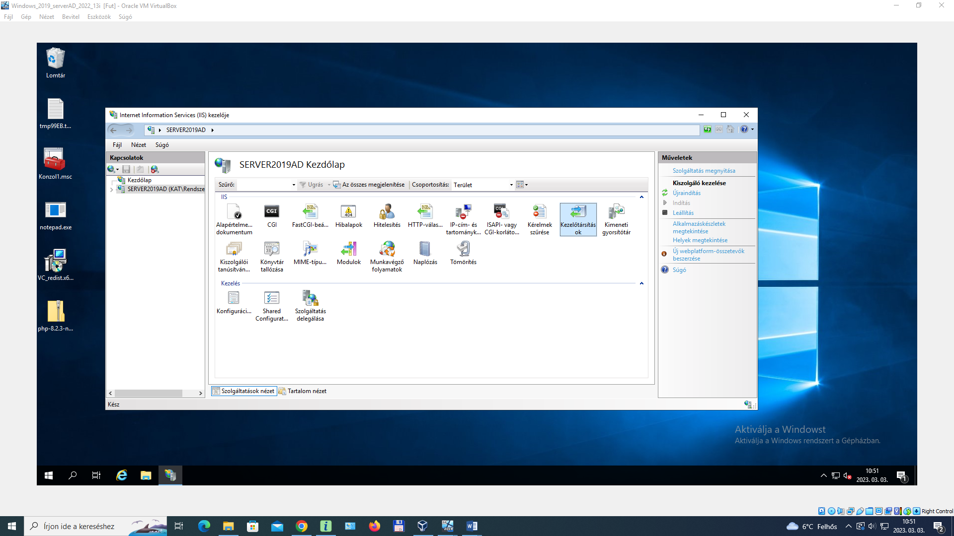
2. Click Add Module Mapping at the top right of the dialog



1. Complete the Add Module Mapping form as follow



**Request Path: *.php  
Module: FastCGIModule  
Executable: C:\Program Files\PHP\php-cgi.exe  
Name: PHP**

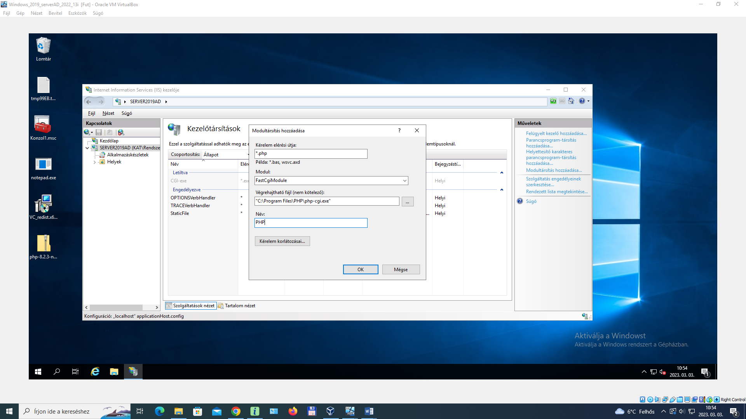

1. Click OK



1. Click Yes to confirm creating the FastCGI application



1. Click the server name again to select it and return to the main options menu > Double click Default Document



1. Click Add... at the top right of the dialog



1. Type index.php > Click OK



1. 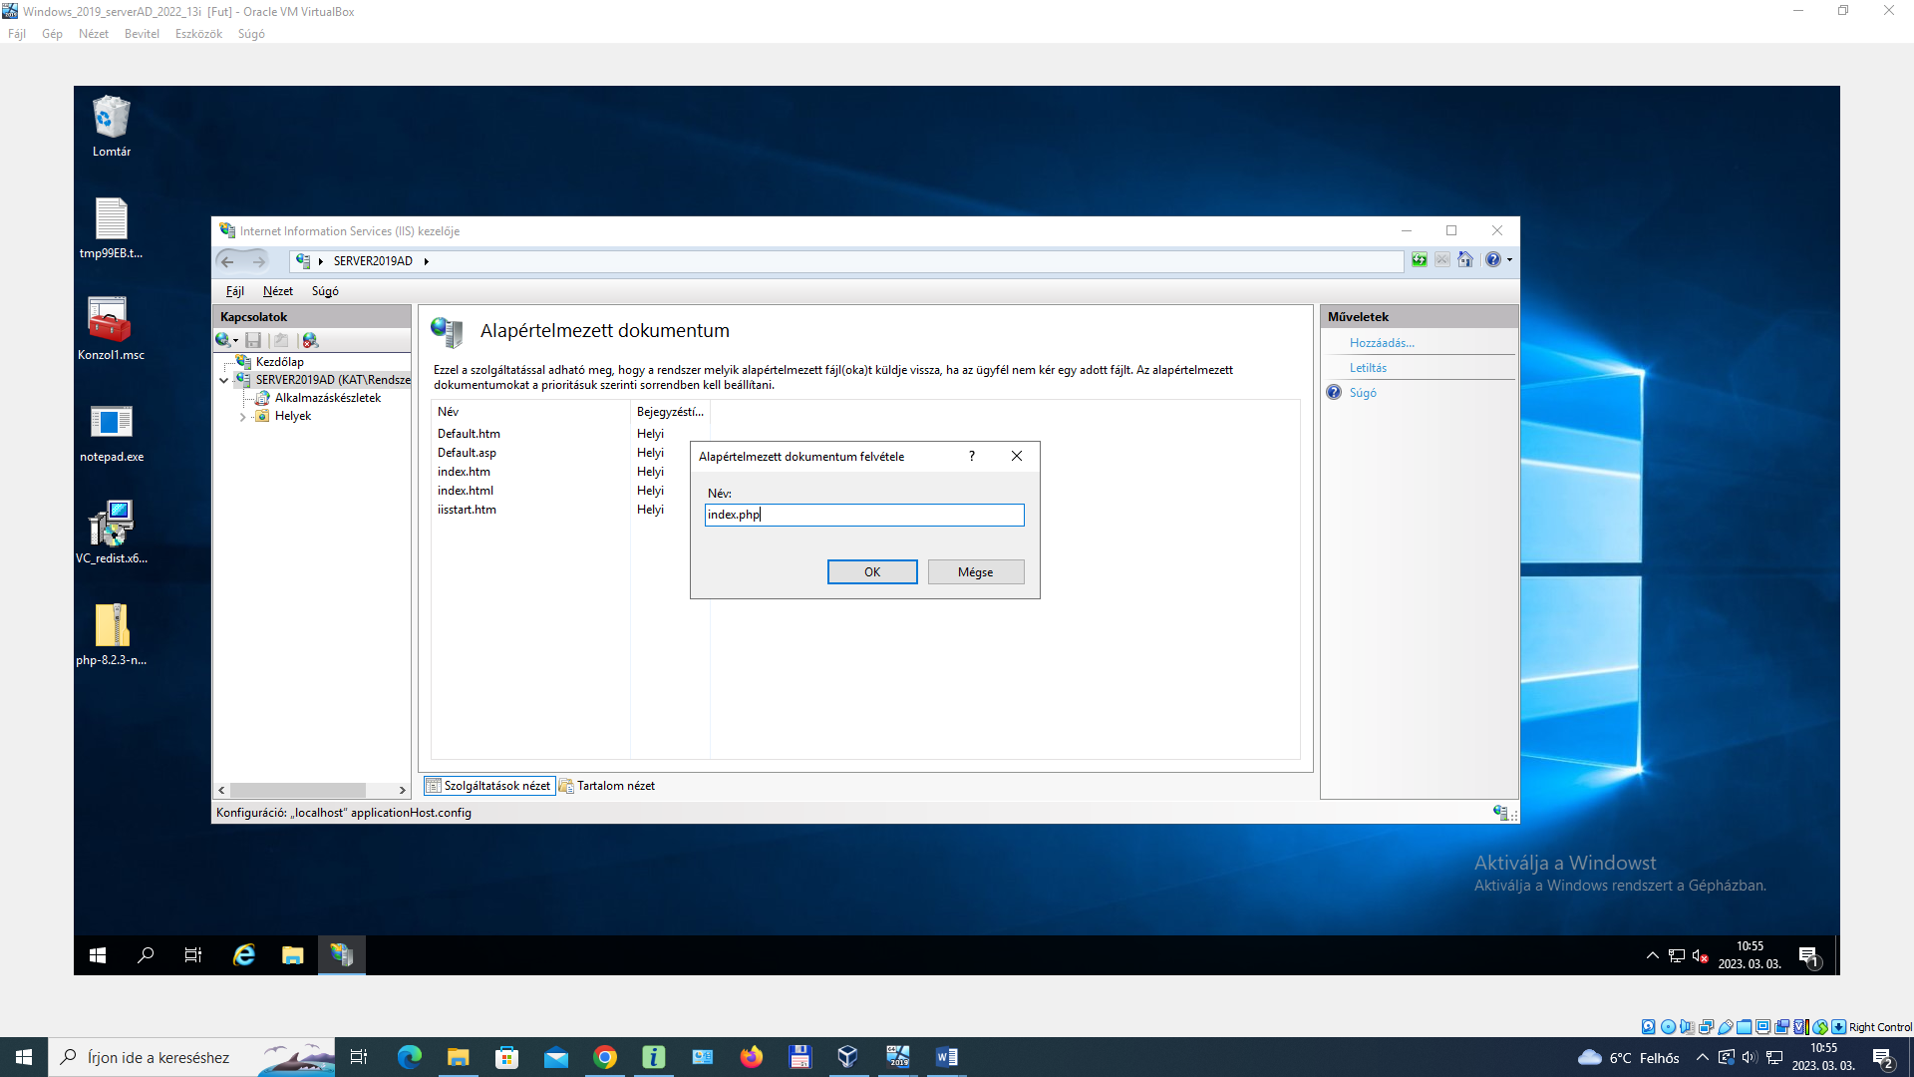
2. Right click on the server name > Stop



1. Right click on the server name again > Start



1. Expand the server name > Expand sites > Right click on Default web Site > Select Explore



1. A File Explorer window will display the wwwroot folder for IIS



1. Right click in the whitespace > New > Text Document > Name the new file phpinfo.php



1. Edit phpinfo.php in Notepad and paste the following



**<?php  
 phpinfo();  
?>**

1. Save the changes to phpinfo.php and close Notepad



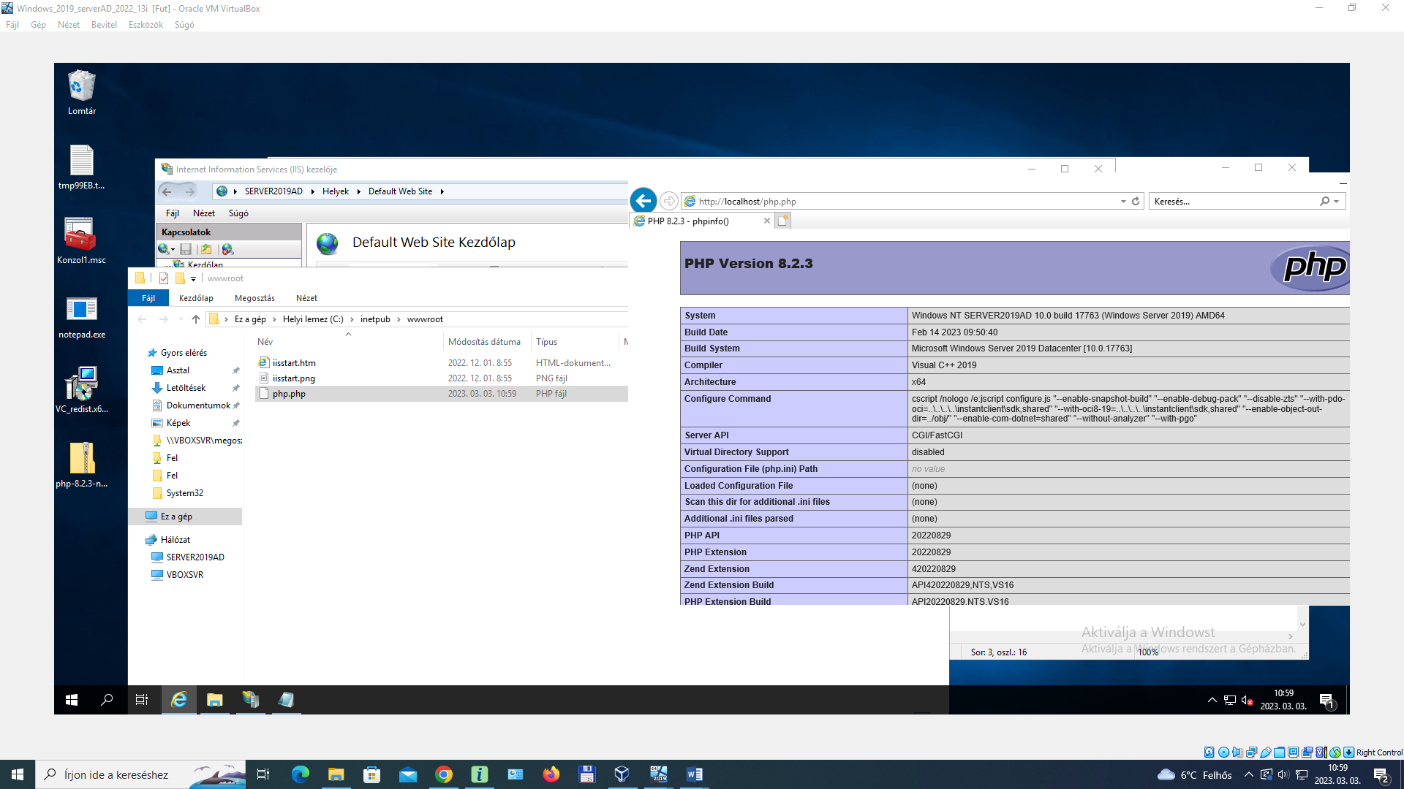

1. Open a web browser and navigate to http://DNSorIP/phpinfo.php

